NOTE: ShimTool on Windows XP® is now supported. The install script will prompt you to indicate you OS.
A Windows XP® installation will install the software on the D: drive, an option exists to install on the C: drive as well if you have a Windows XP ® computer without a D: drive install as if it were a Windows 2000®.

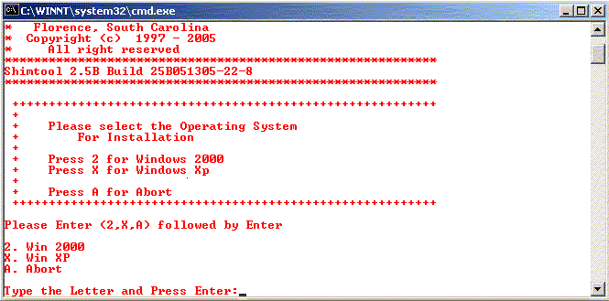
Select OS Screen

Win 2K Install Screen Win Xp Install Screen
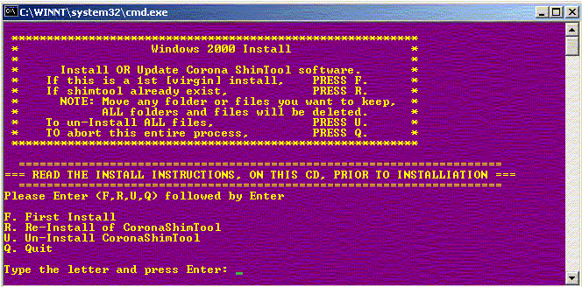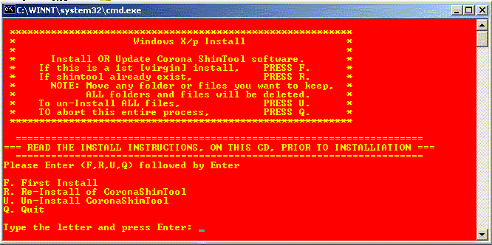

(continued on next page…)

This Install program has three (3) modes—First Install, Reinstall, Un-Install.

First Install: This operation will create the appropriate folders and copy all Corona ShimTool files from the CD to the local C: or D: drive.

Reinstall: This operation will first remove ALL files and folders & subfolders previously installed under C:\Mrshim and then create the appropriate folders and copy all Corona ShimTool files from the CD to the local C: or D: drive.

Un-Install: This operation will first remove ALL files and folders & subfolders previously installed. There if you have files or subfolders under Mrshim, they MUST be relocated else they will be lost.

Once the install options have been selected, the program will auto run and remove/install the required software and place an icon on the desk top for execution of the Corona ShimTool program and also an icon for a Stopwatch which can be used to time shim current inputs. An entry will also be made in the start\programs menu for Corona ShimTool.
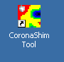 (DeskTop) (Start\Programs)

The passive shim for Corona may have been performed in the factory by using either 25 or 41 axial positions. To determine the method used to shim a magnet, please obtain the ATR [Shipped with magnet] and review the passive shim output file. The field shim must be continued using the same 25 or 41 axial position used in the factory.

If the magnet was shimmed using 25 axial positions, the file will indicate a Magnet Type “Corona” and show 25 axial positions for passive shim locations and the passive shim CALIBRATION FILE of W_CoronaP.cal . The shim drawers in the magnet are also numbered in an axial plane 1-25 to indicate the passive shim locations.

SHIM MAGNET TYPE : Cylindrical
MAGNET TYPE : Corona
AUTO-TOLERANCE : 0.0000 @ 0.0000 PPM
CRITICAL TARGET : 0.0000 PPM
INPUT FIELD FILE : W00069000000EN.map
OUTPUT FILE : \\flomag02medge\testdata\FinalT\W000690\W00069000000EN.shm
PREVIOUS FILE : W00069000000DN.cur
CALIBRATION FILE : W_CoronaP.cal

If the magnet was shimmed using 41 axial positions, the file will indicate a Magnet Type “CoronaP41” and show 41 axial positions for passive shim locations and the passive shim CALIBRATION FILE OF W_CoronaP41.cal. The shim drawers in the magnet are also numbered in an axial plane 1-41 to indicate the passive shim locations.

SHIM MAGNET TYPE : Cylindrical
MAGNET TYPE : CoronaP41
AUTO-TOLERANCE : 0.0000 @ 0.0000 PPM
CRITICAL TARGET : 0.0000 PPM
INPUT FIELD FILE :\\flomag02medge\testdata\FinalT\W000690\W00069000000EN.map
OUTPUT FILE :\\flomag02medge\testdata\FinalT\W000690\W00069000000EN_41p.shm
PREVIOUS FILE : \\flomag02medge\testdata\FinalT\W000690\W00069000000DN_4

